Simple Regression Part I

Question 1 (5 points)
Please access the CO2 Emissions dataset, which has the following variables:
- Car
- Model
- Volume (engine size in cubic centimeters)
- Weight (kg)
- C02 (g C02/km
Use JMP's Graph Builder to produce a scatterplot of C02 vs. Weight. Do not show any curves on the plot. Identify the correct plot and the correct description of the relationship between C02 and Weight. Place an “X” in the box at the upper left of your chosen answer.
Question 1: Answer Choices
 | See below. The relationship is positive (upwards to the right), and appears to be quite strong. |  | See below. The relationship is negative (upwards to the right), but doesn't appear to be very strong.
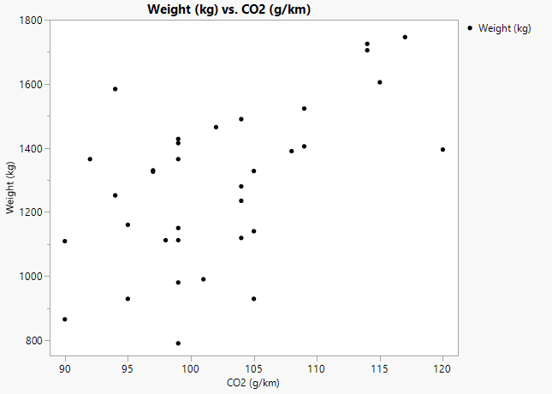 |  | 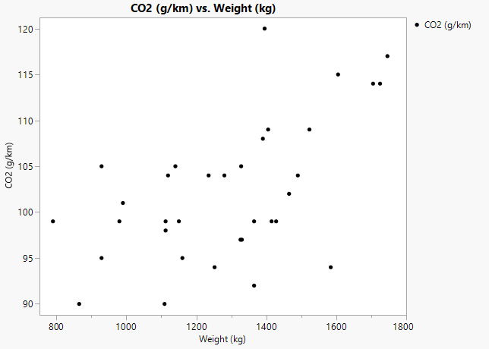
 | See below. The relationship is positive (upwards to the right), but doesn't seem to be very strong. |  | See below. The relationship is positive (upwards to the right), but doesn't appear to be very strong.

Question 2 (5 points)
Please access the CO2 Emissions dataset which has the following variables:
- Car
- Model
- Volume (engine size in cubic centimeters)
- Weight (kg)
- C02 (g C02/km
Use JMP's Fit Model to fit the simple regression model CO2=α+β×Weight+ϵ. Don’t use any transformations. What are the parameter estimates? Place an “X” to the immediate left of your chosen answer.
Question 2: Answer Choices
 | 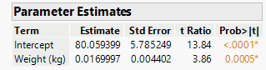 |  | 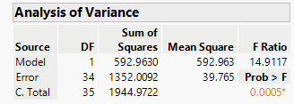
 | 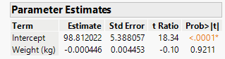 |  | 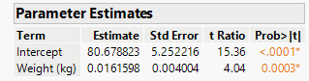

Question 3 (5 points)
Please access the CO2 Emissions dataset which has the following variables:
- Car
- Model
- Volume (engine size in cubic centimeters)
- Weight (kg)
- C02 (g C02/km
Use JMP's Fit Model to fit the simple regression model CO2=α+β×Weight+ϵ. Don’t use any transformations. Interpret the estimated slope in context. Place an “X” to the immediate left of your chosen answer.

Question 3: Answer Choices
For each 1 g increase in a car’s weight, the model predicts a 0.02 kg/km increase in C02.
For each 1 kg increase in a car’s weight, the model predicts a very small decrease in C02.
For each 1 kg increase in a car’s weight, the model predicts a 0.02 g/km increase in C02.
For each 10 kg increase in a car’s weight, the model predicts a 0.002 g/km increase in C02.

Question 4 (5 points)
Please access the CO2 Emissions dataset which has the following variables:
- Car
- Model
- Volume (engine size in cubic centimeters)
- Weight (kg)
- C02 (g C02/km
Use JMP's Fit Model to fit the simple regression model CO2=α+β×Weight+ϵ. Don’t use any transformations. Interpret R² in context. Place an “X” to the immediate left of your chosen answer.

Question 4: Answer Choices
Just over 30% of the variability in the data can be explained by the model.
Just over 30% of the variability in the Weight can be explained by the modeled relationship of Weight to C02.
Just over 30% of the variability in the C02 values can be explained by the variability in Weight.
Just over 30% of the variability in the C02 values can be explained by the modeled relationship of C02 to Weight.

Question 5 (10 points)
Please access the Cellphone dataset which has the following variables:
- Productid
- Price (dollars)
- Weight (grams)
- ScreenSize (inches)
- PixelDensity (ppi)
- CpuCore (integer)
- CpuFreq (GHz)
- InternalMem (GB)
- Ram (GB)
- Thickness (mm)
Please answer each of the following questions. So that your answers remain focused, you are to include ONLY the output that is requested (else, your earned credit will be reduced).
- (5 points) Use JMP's Graph Builder to produce a scatterplot of Price vs. Thickness. Axes should be fully labeled. Copy the plot from the JMP output and paste that plot in the space below.

- (5 points) In one sentence, please specify the direction and apparent strength of the relationship between Price and Thickness solely from a visual inspection of the scatterplot.

Problem 6 (10 points)
Please access the Cellphone dataset which has the following variables:

- Productid
- Price (dollars)
- Weight (grams)
- ScreenSize (inches)
- PixelDensity (ppi)
- CpuCore (integer)
- CpuFreq (GHz)
- InternalMem (GB)
- Ram (GB)
- Thickness (mm)

Please answer each of the following questions. So that your answers remain focused, you are to include ONLY the output that is requested (else, your earned credit will be reduced).
- (5 points) Please use JMP's Fit Model to regress Price on Thickness in a simple regression model with an intercept term. Copy the Parameter Estimates table from the JMP output and paste that table in the space below.

- (5 points) In one sentence, please give an interpretation of the estimated slope in context.

Problem 7 (10 points)
Please access the Cellphone dataset which has the following variables:

- Productid
- Price (dollars)
- Weight (grams)
- ScreenSize (inches)
- PixelDensity (ppi)
- CpuCore (integer)
- CpuFreq (GHz)
- InternalMem (GB)
- Ram (GB)
- Thickness (mm)

Please answer each of the following questions. So that your answers remain focused, you are to include ONLY the output that is requested (else, your earned credit will be reduced).
- (5 points) Please use JMP's Fit Model to regress Price on Thickness in a simple regression model with an intercept term. Copy the Summary of Fit table from the JMP output and paste that table in the space below.

- (5 points) In one sentence, please give an interpretation of the R² value in context.

